Image Base Captcha using Python

Mini Project submitted in partial fulfilment of the requirements for the Degree of

BACHELOR OF TECHNOLOGY
in
COMPUTER SCIENCE AND ENGINEERING
By

Kallem Vinay Chandh Reddy (11802887)
Section: K18GX
Under the guidance of
RANJIT KAUR

School of Computer Science and Engineering
Lovely Professional University
Phagwara, Punjab (India)
APR 2019

TABLE OF CONTENT

Chapter 1. Introduction 1-2
1.1 What is a Captcha? 1
1.2 Why is Captcha needed? 1
1.3 What is Captcha type? 1
1.4 What is a Picture Representation Captcha? 1
1.5 What was reCAPTCHA created? 2
Chapter 2. Methodology 3-5
2.1 Methodology Used 3
2.2 Flow Chart of our Project 4
2.3 Gantt Chart of our project 5
Chapter 3. Technologies used 6
Chapter 4. Work Division 7
Chapter 5. Implementation 8-9
References 10
CHAPTER 1
INTRODUCTION

1.1) What is a Captcha?
A CAPTCHA ("Completely Automated Public Turing test to tell Computers and Humans Apart") is a type of challenge-response test used in computing to determine whether or not the user is human. The term was coined in 2003 by Luis von Ahn, Manuel Blum, Nicholas J. Hopper, and John Langford. It is a security feature that can prevent the use of websites that may be unlawful. Web developers use this on sites to make sure the being using the website is indeed a human with good intentions.

1.2) Why is Captcha Needed?
CAPTCHA is used to prevent bots from automatically submitting forms with SPAM or other unwanted content. Google and other companies use it to prevent bots from creating multiple Gmail accounts. It’s a small little aid which is put on webpages to identify if a human is browsing it or a program and eventually obstruct the automated program-browsing.

1.3) What are Captcha Types?
There are many CAPTCHA examples but the most widely used are mentioned below:
- Word solving
- Audio
- Picture Identification (Image Base)
- 3D
- Math solution
- Drag and Drop
- JQuery Slider
- Tic Tac Toe

1.4) What is a Picture Representation Captcha (image Base Captcha)?
This captcha provides users for selecting the elementary choice of selecting the correct image that they are asked to identify. This type of captcha usually never gets harder than the basic images, so you do not have to worry about your users not being able to depict them.

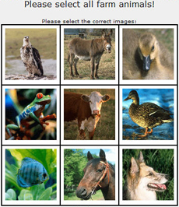

1.5) What are reCAPTCHA created?
- reCAPTCHA is built for security. Armed with state-of-the-art technology, reCAPTCHA is always at the forefront of spam and abuse fighting trends so it can provide you an unparalleled view into abusive traffic on your site.
- Purposefully designed. And actively aware. reCAPTCHA knows when to be easy on people and hard on bots.
- reCAPTCHA makes positive use of this human effort by channeling the time spent solving CAPTCHAs into annotating images and building machine learning datasets. This in turn helps improve maps and solve hard AI problems.
CHAPTER 2
METHODOLOGY

Methodology used to develop your website.
Our Project is “Image Base Captcha using Python”. Basically, Captcha is a Human-Robot Verification while Browsing something that is having some privacy.
So, we generated a code that verifies whether the user is basically a Human or Robot.
Basically, when this GUI opens, it tells us to select the images that should contain the Object that it is asking for. If we select only the images that contains the mentioned object, then it gets verified that the user is a human, if not, it confirms that the user is a Robot.
If it verifies that user is a Human, then it permits to get through the webpage.
If it verifies that user is a Robot, then it cancels the authorization to go to webpage.
So, in our GUI, when you will have to select images of given object, if you do it right, and click the “Verify” Button, then it displays “Captcha Verified”, that implies the user is a Human. If you do it wrong, then it displays “Captcha Mismatch”, that implies the user is a Robot.
For Building this GUI, We have used Various Modules like Tkinter, Random, PIL(python Imaging Library) etc.

Flow Chart:
Choosing the Images of Given Object

Verification

Verified (or)
Not Verified

Positive Negative

Selected Images and given object are not matching

If Verified

Yes No
If not Verified

Selected Images are Correct
No Yes

Selected Images are Wrong

Captcha Verified

Selected Images should match the Given Object
Captcha not Verified
Positive Negative
Negative Positive
Task Completed

CHAPTER 3
TECHNOLOGIES USED

Write brief description about the technologies used in your project

We have used the “IDLE (Python 3.7 32-Bit)” for the Generation of code.

CHAPTER 4
WORK DIVISION

Detailed description of all the modules:

- Gathering Information about our project:
We gathered all the required information regarding our project from various websites (Mentioned in References). Also, about the Modules like PIL, Tkinter, random that are used in generating our Code.
- Creating Code for our project:
We created the Code with the help of Tkinter, random, PIL (Python Imaging Library) Modules, where we have used them purposefully. Also, Some Functions are added into it.
- Writing the Final Report:
We have added all the Contents of our work done (i.e., Report Format that is being uploaded).

Part of Every Person in above mentioned Modules:

- Vinay - Helped in Gathering Information, Done the Tkinter module part in Coding,
Typed the Code.
- Raghu - Helped in Gathering Information, Done the verification part in the Code (i.e., Created a function to verify whether the selected images are matching or not).
- Sanketh - Helped in Gathering Information, Typed the Report, Done the PIL and Tkinter module part in the Code.
- Lakshmi - Helped in Gathering Information, Done in the random module part in the Code.

CHAPTER 5
IMPLEMENTATION.

Screenshots of our webpages (Image Base Captcha):
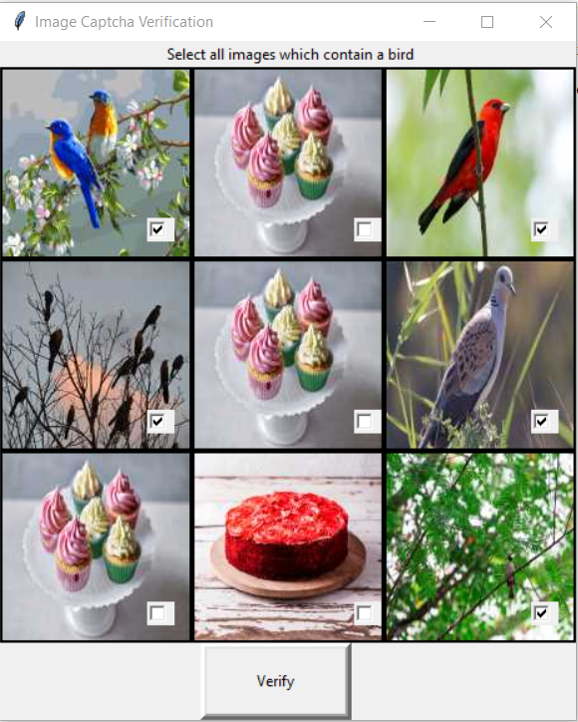

- In this GUI, it is showing to select all images that contain a “Bird”, so, I have selected all the images containing a Bird as you can see in this Picture. So, now you have to click the “Verify” Button.

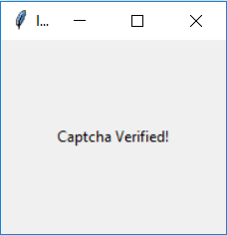

- As you have Clicked the “Verify” Button, it will check whether the selected images are containing at least one Bird or Not. As, I have selected inly the images with Bird, it gets finalized and Displays “Captcha Verified!”.
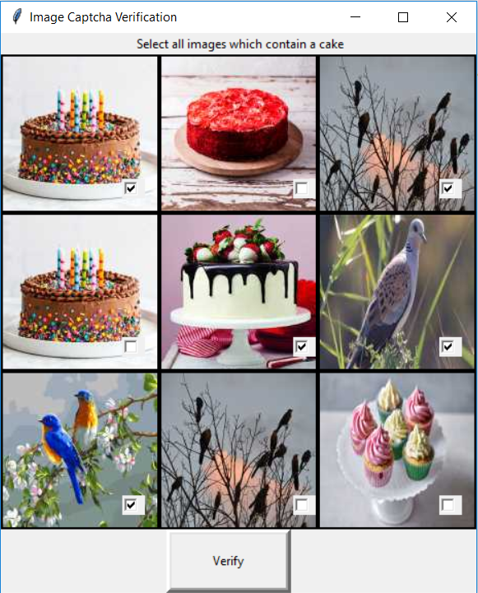

- In this GUI, it is showing to select all images that contain a “Bird”, but, I have selected only some images containing a Bird and also some other images as you can see in this Picture. So, now you have to click the “Verify” Button.

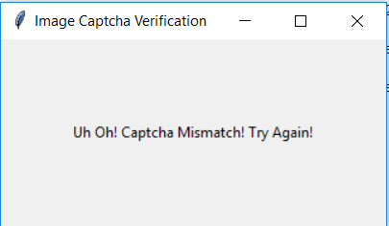

- As you have Clicked the “Verify” Button, it will check whether the selected images are containing at least one Bird or Not. As, I have selected only some images with Bird and also some other images, it gets finalized and Displays “Captcha Mismatch!”.
REFERENCES

https://www.github.com/kuszaj/claptha
https://www.letsnurture.com
https://www.programcreek.com
https://www.stackoverflow.com

